**Lesson 2 Reports I**

**Lesson objectives:**

* Get to know the genres in writing.
* Recognize different “reports”.
* Learn how to write classifying reports of academic articles.
* Learn how to use proper expressions in writing classifying reports.

1. **Map of genres in school**

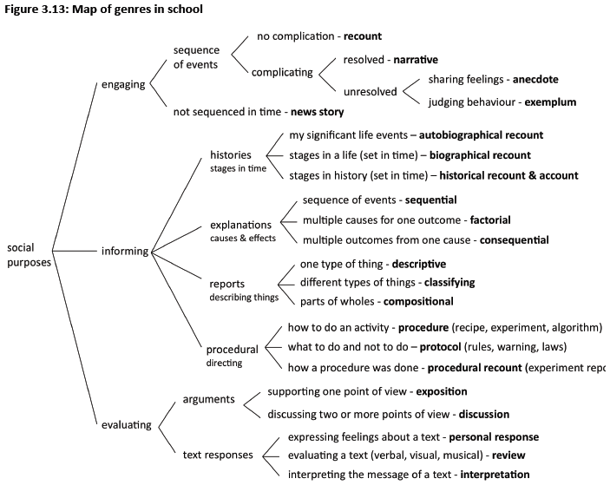

1. **Reports: classifying and describing things**

Science classifies and describes phenomena in three types of reports. Classifying reports sub-classify a number of phenomena with respect to a given set of criteria. Descriptive reports classify a phenomenon and then describe its features. Compositional reports describe the components of an entity.

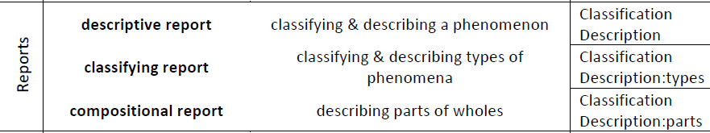

**3. Classifying reports**

**Sample Text 1: Producers and consumers**

We have seen that organisms in an ecosystem are first classified as producers or as consumers of chemical energy.

Producers in ecosystems are typically photosynthetic organisms, such as plants, algae and cyanobacteria. These organisms build organic matter (food from simple inorganic substances by photosynthesis).

Consumers in an ecosystem obtain their energy in the form of chemical energy present in their ‘food’. All consumers depend directly or indirectly on producers for their supply of chemical energy.

Organisms that eat the organic matter of producers or their products (seeds, fruits) are called primary consumers, such as leaf-eating koalas (Phascolarctos cinereus), and nectar-eating honey possums (Tarsipes rostratus). Organisms that eat primary consumers are known as secondary consumers. Wedge-tailed eagles that prey on wallabies are secondary consumers.

Some organisms consume the organic matter of secondary consumers and are labeled tertiary consumers. Ghost bats (Macroderma gigas) capture a variety of prey, including small mammals.

**Sample Text 2: Blood Type**

Blood Type, in medicine, is the classification of red blood cells by the presence of specific substances on their surface. Typing of red blood cells is a prerequisite for blood transfusion. In the early part of the 20th century, physicians discovered that blood transfusions often failed because the blood type of the recipient was not compatible with that of the donor. In 1901 the Austrian pathologist Karl Landsteiner classified blood types and discovered that they were transmitted by Mendelian heredity. The four blood types are known as A, B, AB, and O.

Blood type A contains red blood cells that have a substance A on their surface. This type of blood also contains an antibody directed against substance B, found on the red cells of persons with blood type B.

Type B blood contains the reverse combination.

Serum of blood type AB contains neither antibody, but red cells in this type of blood contain both A and B substances.

In type O blood, neither substance is present on the red cells, but the individual is capable of forming antibodies directed against red cells containing substance A or B. If blood type A is transfused into a person with B type blood, anti-A antibodies in the recipient will destroy the transfused A red cells. Because O type blood has neither substance on its red cells, it can be given successfully to almost any person. Persons with blood type AB have no antibodies and can receive any of the four types of blood; thus blood types O and AB are called universal donors and universal recipients, respectively.

**4. Expressions in classifying reports**

The tables below show some of the most common language used in texts which have classification as their purpose.

|  |  |  |  |  |
| --- | --- | --- | --- | --- |
| There are | two | types kinds classes categories sorts varieties | of lava | : acidic and basic. . These are acidic and basic. |
| The | are acidic and basic. |

|  |  |  |  |  |
| --- | --- | --- | --- | --- |
| Lava | consists of comprises can be divided into | two | categories classes kinds types varieties | . These are acidic and basic. : acidic and basic. |

|  |  |  |
| --- | --- | --- |
| Acidic and basic are | classes kinds types categories varieties | of lava. |

|  |  |  |
| --- | --- | --- |
| Lava may be classified | according to on the basis of  depending on | amount of silica present. |

**5. In-class Practice**

**Exercise 1**

Read the following passage and answer the questions.

Eruptions of volcanoes may be divided into three main types: (1) the explosive type, in which rock fragments are thrown out with explosive violence; (2) the quiet type, in which hot liquid rock quietly flows on the surface; (3) the intermediate type, in which eruptions are at times violent and at other times consist of the quiet outflowing of lava.

* What is the text classifying?
* How many types are there?
* What are the different types?
* How do we make the distinction?
* What expressions are used to show this text is of classification?

**Exercise 2**

Read the following passage and answer the questions.

Lavas may be divided into two contrasting types, acid and basic. Acid or siliceous lavas have a high silica content, about 70 to 75 per cent, and are stiff or viscous. They move slowly over the surface and solidify close to the vent. Basic lavas have a silica content of about 50 per cent. Dark colored and fluid, they flow more easily at lower temperatures and reach a greater distance from the crater than do acid lavas.

* What is the text classifying?
* How many types are there?
* What are the two types?
* How do we make the distinction?
* What expressions are used to show this text is of classification?

**Exercise 3**

Read the following texts and complete the tree diagram with the 11 words given below:

|  |
| --- |
| We shall outline the four major subfields of anthropology that have emerged in the twentieth century: physical anthropology, archaeology, linguistics and cultural anthropology.  Physical anthropology deals with human biology across space and time. It is divided into two areas: paleontology, the study of the fossil evidence of the primate (including human) evolution, and neontology, the comparative biology of living primates, including population and molecular genetics, body shapes (morphology), and the extent to which behavior is biologically programmed.  Archeology is the systematic retrieval and analysis of the physical remains left behind by human beings, including both their skeletal and cultural remains. Both the classical civilizations and prehistoric groups, including our prehuman ancestors, are investigated.  Linguistics is the study of language across space and time. Historical linguistics attempts to trace the tree of linguistic evolution and to reconstruct ancestral language forms. Comparative (or structural) linguistics attempts to describe formally the basic elements of languages and the rules by which they are ordered into intelligible speech.  Cultural anthropology includes many different perspectives and specialized subdisciplines but is concerned primarily with describing the forms of social organization and the cultural systems of human groups. In technical usage, ethnography is the description of the social and cultural systems of one particular group, whereas ethnology is the comparison of such descriptions for the purpose of generalizing about the nature of all human groups.  (From D.E. Hunt and P. Whitten: T*he Study of Anthropology*(Harper and Row, 1976) |

1. ethnology 民族学
2. linguistics 语言学
3. archeology 考古学
4. cultural anthropology 文化人类学
5. structural linguistics 结构语言学
6. historical linguistics 历史语言学
7. physical anthropology 体质人类学
8. paleontology 古生物学
9. neontology 近代生物学
10. ethnography 人种学
11. anthropology 人类学

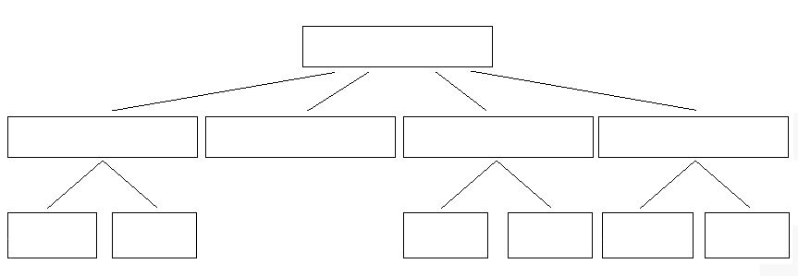

**Exercise 4:**

Write a description of drinks using the information given in the diagram below:

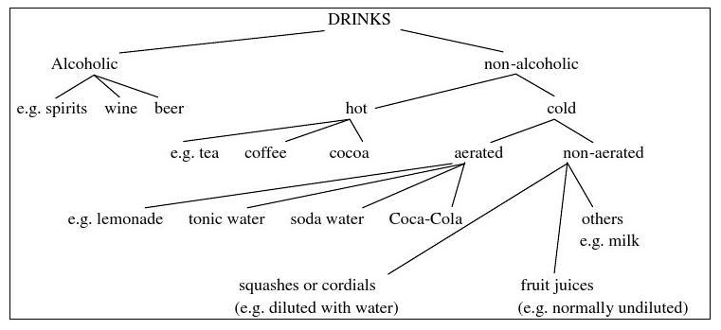

**Homework assignments:**

Write a classifying report to briefly classify sports. Imitating the tree diagram in Exercise 3 or 4, you are required to draw a similar diagram and complete it with the terms used in your classifying report. Your report should have 150-200 words. It will **be due in Week 3**.

The evaluation of the report will be considered from the following aspects:

* Label stages (classification, description)
* Underline types and sub-types
* Draw a tree diagram
* Mention criteria
* Reference
* Grammar & sentence variation

**Homework format requirements：**All assignments are to be typed in 12 point Times New Roman font, double-spaced on A4 paper.

**References:**

Rose, D., and Martin, J. R. (2012). *Learning to Write, Reading to Learn: Genre, Knowledge and Pedagogy in the Sydney School*. Equinox Publishing Ltd.

Martin, J. R., and Rose, D. (2008). *Genre Relation, Mapping Culture*. Equinox Publishing Ltd.